Permission to Screen Education, Inc.

January 1, 2017
To Whom It May Concern:

Members of the Save Our Schools KY Coalition have my permission to screen the film Education Inc to any and all audiences in any form or fashion as long as they do not charge admission.

Sincerely,
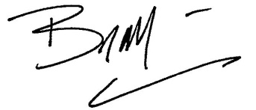
Brian Malone
Producer
Education, Inc.
(303) 888-9649

